ORPHEK
PR-DIF100
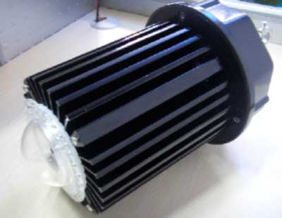
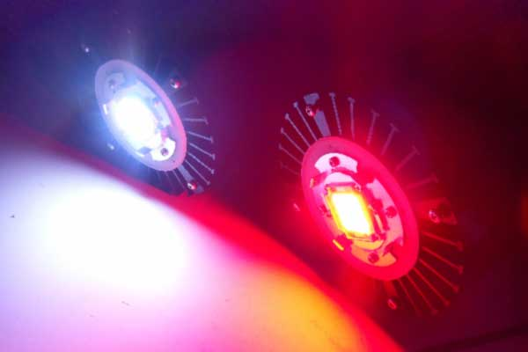
Designed for commercial greenhouses and aquaculture facilities!
The DIF-100 LED grow light is:
Powerful: 10,000 lumens @ 15,000k, with a spectral curve designed and tailored specifically for high-PUR output, unlike traditional halide and sodium lamps
Efficient: 90 lumens/watt, the most efficient single die LED light available
Versatile: available in three different wattages and three different optic/lens options allow for spread (frag/growout tanks, hydroponics, and greenhouses) or depth penetration (zoos, public aquariums, and more)
Durable: solid, waterproof construction with a corrosion resistant coating and high quality constant-current electronics allow for decades of operation even in humid or salty environments

DIMENSIONS

With reflector (optional for commercial greenhouse use)

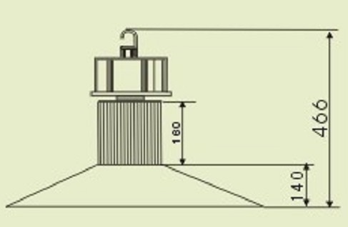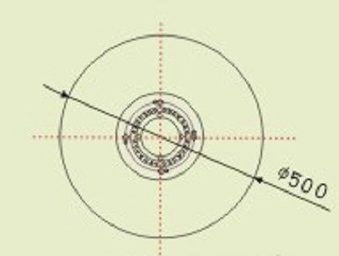

SPECIFICATIONS

1. LED DATA

ITEM | MIN | AVG | MAX
Power | - | 95W | 100W
Rated Current | - | 3000mA | 3500mA
Rated Voltage | 30V | 32 V | 36V
Beam Angle | - | 140deg | -
Cool White Temperature | 13000K | 15000K | 18000 K
Normal Operation Crystal | - | 85 ℃ | 105 ℃
LED Efficiency | 80LM/W | 85LM/W | 90LM/W
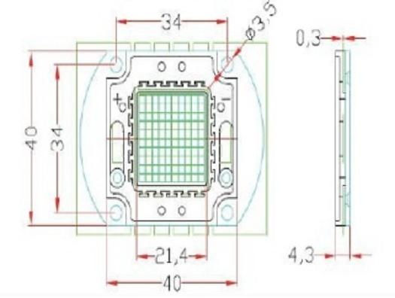
2. POWER SUPPLY DATA

 | Posting Mode | Built-in Drive
 | Input Voltage | AC85V～265V
 | Freqency Range | 50Hz～60Hz
 | Max input Power | 100W
 | Total Harmonic Distortion | ≤ 9 %
 | Power Factor | ＞0.98
 | Power Efficiency | ＞85 %
 | Output Mode | constant current
 | Output Voltage | DC 32-36V
 | Certificate | CE

3. LAMPS TECHNOLOGY DATA

 | Working Voltage |  |  | DC32-36V
 | Lamp Quantity |  |  | 1 pc
 | Consumption |  |  | 100W
 | System Consumption |  |  | 100W
 | Led Luminous Efficiency |  |  | 90-100 Lm /W
 | Led Initial Flux |  |  | 9000-10000 Lm
 | Lamp Efficiency |  |  | ＞90 %
 | Average Illuminance | 6M |  | 53.8LUX
 | Average Illuminance | 8M |  | 24.6LUX
 | Average Illuminance | 10M |  | 13.6LUX
 | Illuminance Area | 6M |  | 10*10 M
 | Illuminance Area | 8M |  | 16*16M
 | Illuminance Area | 10M |  | 21*21M
 | Illuminance Uniformity |  |  | ＞0.6
 | Color Temperature |  |  | See above data
 | Color Rendering Index |  |  | Ra＞75
 | Light Distribution |  |  | rectangle luminous spot
 | Light Design |  |  | LED + reflecting shade
 | Junction Temperature |  |  | ≤80℃
 | Working Temperature |  |  | -30℃ ～ 55℃
 | Storage Temperature |  |  | -25℃ ～ +65℃（25℃best）
 | IP Grade |  |  | IP65
 | Net weight |  |  | 5.5Kg
 | Working Lifespan |  |  | 50000H
 | Power line |  |  | 0.75mm² three line
 | Connect Wire |  | Brown | L (Live line)
 |  |  | Blue | N (Null line)
 |  |  | Yellow/Green | G (Ground line)
 | Certificate |  |  | CE
 | Color of lamp shell |  |  | Black

Notes: efficiency can deviate with color temperature ≤5%

4. PHOTOMETRIC DATA

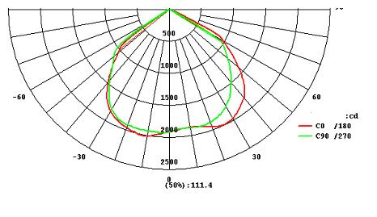

5. LUX Distribution Diagram (LUX)

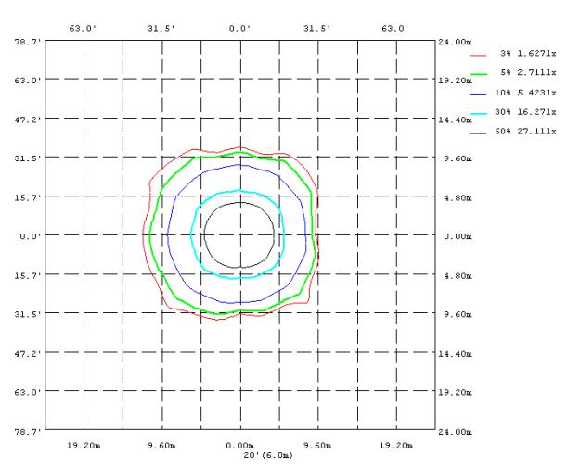

6. Spectrographs

Orphek DIF-100 (aquarium and aquaculture)
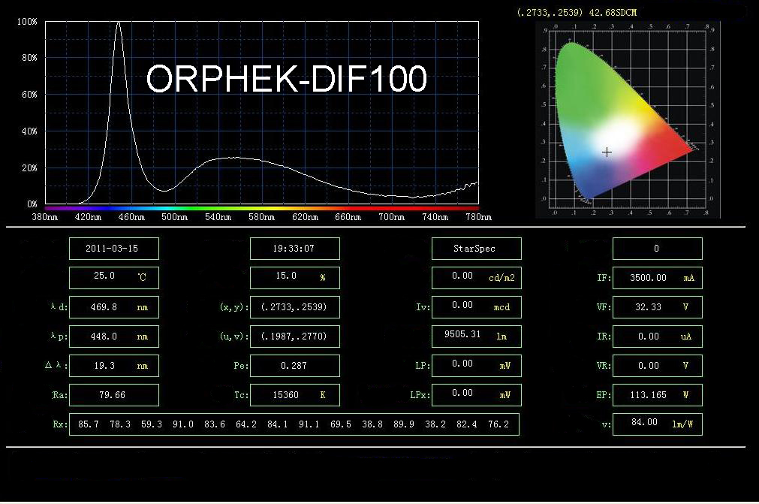

Orphek DIF-100B (aquaculture & horticulture)
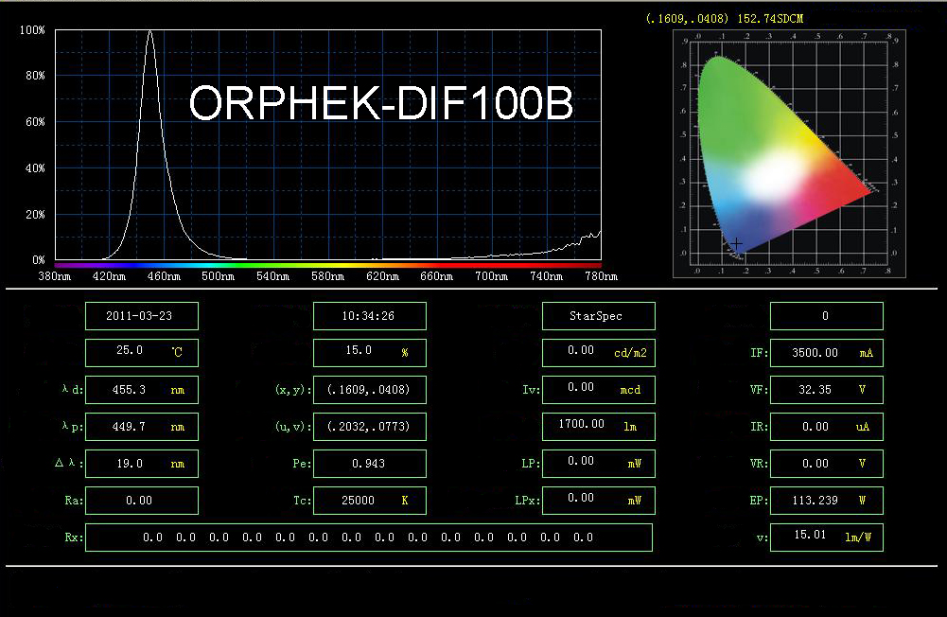

Orphek DIF-100R (horticulture)
